AUTOMOBILE SELLING PRICE PREDICTION SYSTEM
A Machine Learning Approach for Accurate Used Car Valuation

Artificial Intelligence and Machine Learning Lab

Course Code: CSE3202
Section: 03
Semester: Summer 2026

Submitted To:

Foysal Ahmed

Lecturer
Department of Computer Science & Engineering
University of Liberal Arts Bangladesh

Submitted By:

Group 4
Name | Student ID
Raju Ahammed | 242014131
Md Syful Alam Rafi | 241014084
Punam Mazumdar | 233014152

Submission Date: August 9, 2026

1. INTRODUCTION

The Automotive industry is one of the biggest markets globally with thousands of used vehicles being traded every year. Nevertheless, assessing the price of a used car is not an easy task because of various factors that contribute to the value, including car specification, condition, and even location of the transaction. Buyers and sellers often do not have full information leading to the formation of incorrect prices.

Typically, people use traditional methods for valuing cars that require manual estimation, expertise of dealers and historical data analysis. However, such valuation is highly subjective and takes much time. Chen & Guestrin (2016) note that machine learning algorithms, specifically gradient boosting techniques, have shown excellent results in performing structured data regression because of the ability to learn complex dependencies between features and target variables automatically.

Thanks to machine learning advancements, data-driven systems are able to give fast, objective and accurate estimations based on historical data analysis. In this project, we design an efficient machine learning pipeline that allows predicting the selling price of used cars based on the dataset with 5,500 cars. We use the XGBoost regressor with optimized hyperparameters to achieve state-of-the-art performance.

Key Contributions of Our Project:

Idx | Contribution | Description
1 | Comprehensive Data Pipeline | Systematic preprocessing with appropriate imputation strategies
2 | In-depth EDA | Uncovering key price drivers through visualization and correlation analysis
3 | Multiple Algorithm Evaluation | Comparison of 5 regression algorithms
4 | Hyperparameter Tuning | Systematic optimization using RandomizedSearchCV
5 | Deployment | Production-ready Streamlit web application

2. PROBLEM STATEMENT/USE CASE

2.1 Why is this problem important?

The used car market is plagued by price variability and information asymmetry problems. James et al. (2013) state that to make accurate predictions in such cases, the interrelationships between several variables must be analyzed in a non-linear way. These issues appear in the following way:

Stakeholder | Challenge | Impact
Buyers | Limited market knowledge | Risk of overpaying
Sellers | Lack of objective valuation | Potential undervaluation
Dealerships | Inconsistent pricing strategies | Reduced profitability
Financial Institutions | Inaccurate loan assessments | Increased default risk

Market Significance:

- Used Car Market Global Size: over $1 trillion per year
- Number of Transactions: millions per year
- Asymmetry of Information: traditional approaches do not provide enough transparency
- Price Variability: Prices depend on location

2.2 What Problem Is Our Project Solving?

The core issue that our project solves is the problem of precise used car pricing prediction using machine learning. Through the analysis of 17 vehicle characteristics (make, model, year, mileage, engine specs, condition, location, etc.), we are able to give an instant price estimate which is both accurate and understandable.

Our project solves the following problems:
1. Precision of valuation: We get an R² score of 98.51%, which is far better than the traditional approach
2. Speed: We give instant price estimates via a website
3. Transparency: We perform a feature importance analysis for our predictions
4. Availability: We implement our project as a free web application
5. Scalability: We may update our model when getting new data
6. Flexibility: We have an open-source solution which can be customized

2.3 Benefits of Our Proposed Solution

Benefit | Description
Data-Driven Accuracy | We eliminate subjective bias in pricing
Real-Time Estimation | We provide instant predictions for any vehicle
Explainability | We enable understanding of price-driving factors
Cost-Effective | Our solution is free and accessible to all users
Adaptability | We can easily retrain with new market data
Transparency | Our methodology is open-source and auditable

3. DATASET COLLECTION, CLEANING, AND PREPROCESSING

3.1 Dataset Overview

The dataset we use is the “Automobile Market Analytics Dataset” obtained from Kaggle and includes 5,500 records with 18 features. The feature of interest is Selling_Price, which indicates the resale price.

Dataset Source: Kaggle – Automobile Market Analytics Dataset

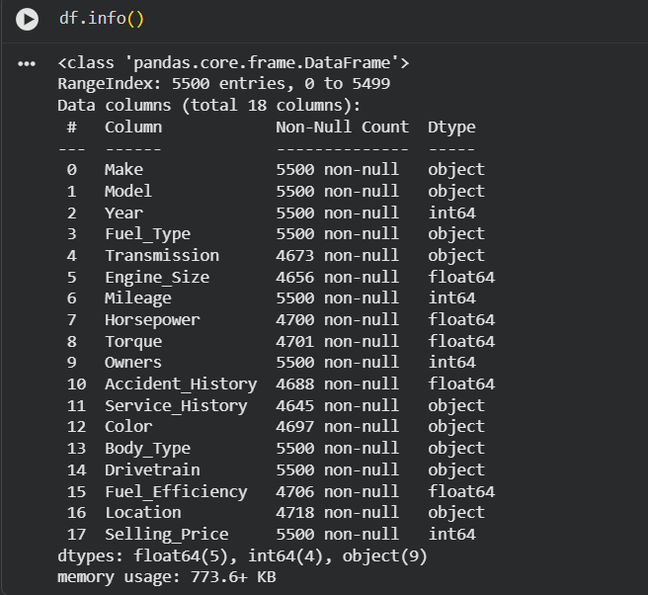

Dataset Attributes:
- Number of Observations: 5,500
- Number of Attributes: 17 (excluding the target attribute)
- Types of Attributes: Numerical & Categorical
- Target Attribute: Selling_Price (Continuous)

3.1.1 Feature Description

Feature | Type | Description
Make | Categorical | Vehicle manufacturer
Model | Categorical | Vehicle model name
Year | Numeric | Manufacturing year
Fuel_Type | Categorical | Fuel category (Petrol, Diesel, Hybrid, Electric)
Transmission | Categorical | Manual or Automatic
Engine_Size | Numeric | Engine displacement in liters
Mileage | Numeric | Total distance driven (miles)
Horsepower | Numeric | Engine power output
Torque | Numeric | Engine torque
Owners | Numeric | Number of previous owners
Accident_History | Categorical | Previous accident record (Yes/No)
Service_History | Categorical | Maintenance history
Color | Categorical | Exterior color
Body_Type | Categorical | Vehicle body style
Drivetrain | Categorical | Drive system (FWD, AWD, RWD, 4WD)
Fuel_Efficiency | Numeric | Estimated fuel economy (MPG/MPGe)
Location | Categorical | U.S. state abbreviation
Selling_Price | Numeric (Target) | Estimated resale price

3.1.2 Data Statistics

Shape: 5,500 rows × 18 columns

Data Types Distribution:

Data Type | Count
object (categorical) | 9
int64 (numerical) | 4
float64 (numerical) | 5

Memory Usage: 773.6+ KB

3.2 Data Inspection

3.2.1 Missing Value Analysis

The following missing values have been observed in our dataset:

Transmission: 827 missing values (15.04%)
Engine Size: 844 missing values (15.35%)
Horsepower: 800 missing values (14.55%)
Torque: 799 missing values (14.53%)
Accident History: 812 missing values (14.76%)
Service History: 855 missing values (15.55%)
Color: 803 missing values (14.60%)
Fuel Efficiency: 794 missing values (14.44%)
Location: 782 missing values (14.22%)
Other Columns: We have not observed any missing values (0).

Duplicate Check: We find no duplicate records in our dataset (0 duplicates)

3.2.2 Statistical Summary

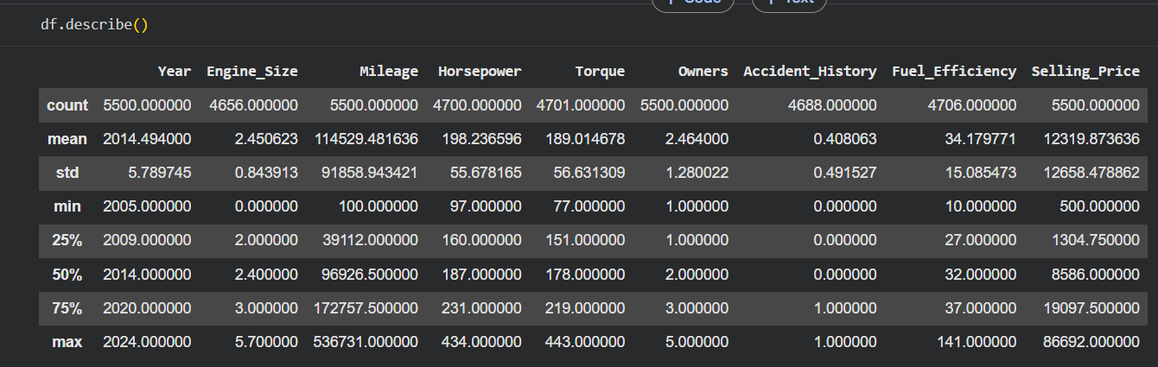

3.3 Data Preprocessing

3.3.1 Handling Missing Values

Our Strategy:
- Numerical Variables (Engine_Size, Horsepower, Torque, Fuel_Efficiency): We use median imputation in order to maintain data distribution
- Categorical Variables (Transmission, Service_History, Color, Location): We use mode (most frequent) imputation

Implementation Code Snippet:

# Numerical imputation with median
num_cols = ['Engine_Size', 'Horsepower', 'Torque', 'Fuel_Efficiency']
for col in num_cols:
df[col].fillna(df[col].median(), inplace=True)

- Fill N/A value with median in these columns Engine_Size, Horsepower, Torque, Fuel_Efficiency

# Categorical imputation with mode
cat_cols = ['Transmission', 'Service_History', 'Color', 'Location']
for col in cat_cols:
df[col].fillna(df[col].mode()[0], inplace=True)

- Fill N/A value with mode in these columns data Transmission, Service_History, Color, and Location.

3.3.2 Data Type Correction

df["Accident_History"] = df["Accident_History"].astype("object")
df["Accident_History"] = df["Accident_History"].map({1.0: "Yes", 0.0: "No"})

Accident history: 1 →’Yes’, 0 →’No’ (initialize here)

3.3.3 Train-Test Split

We split the data into 80% training and 20% testing sets and dependent variable is y and independent variable is X here :

X = df.drop('Selling_Price', axis=1)
y = df['Selling_Price']
X_train, X_test, y_train, y_test = train_test_split(
X, y, test_size=0.2, random_state=42, stratify = y)

3.4 Exploratory Data Analysis (EDA)

3.4.1 Numerical Features Distribution
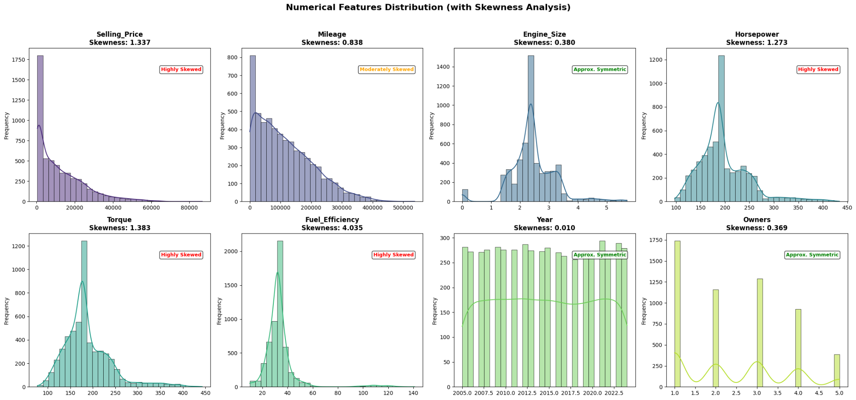

The observed skewness of our numerical features is as follows:

Feature | Skewness | Distribution Shape
Selling_Price | 1.337 | Right-Skewed
Mileage | 0.838 | Mildly Right-Skewed
Engine_Size | 0.380 | Slightly Symmetrical
Horsepower | 1.273 | Right-Skewed
Torque | 1.383 | Right-Skewed
Fuel_Efficiency | 4.035 | Very Right-Skewed
Year | 0.010 | Approx. Symmetrical

3.4.2 Correlation Analysis
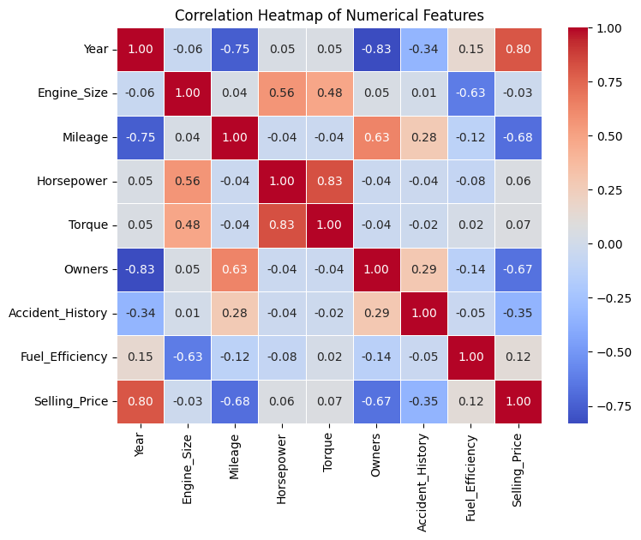
To see the relationship between numerical features and Selling_Price, we utilize the correlation heatmap.
- The correlation of Year (0.80) with Selling_Price is strong and positive. This means that the newer the car, the more expensive it will be.
- The correlation of Mileage (-0.68) with Selling_Price is strong and negative. It means that the higher the mileage, the less expensive the car will be.
- The correlation of Owners (-0.67) with Selling_Price is strong and negative. Cars with more owners have a lower price.
- The correlation of Accident_History (-0.35) with Selling_Price is moderate and negative. An accident history will lead to a reduction of the selling price.
- The correlation of Fuel_Efficiency (0.12), Horsepower (0.06), Torque (0.07), and Engine_Size (-0.03) with Selling_Price is weak.

It can be observed that there are strong dependencies between independent features. For instance, Horsepower and Torque (0.83) are highly correlated. Thus, multicollinearity should be taken into account while choosing features for the ML model.

In general, the most correlated features with Selling_Price are Year, Mileage, and Owners.

3.4.3 Categorical Features vs. Price
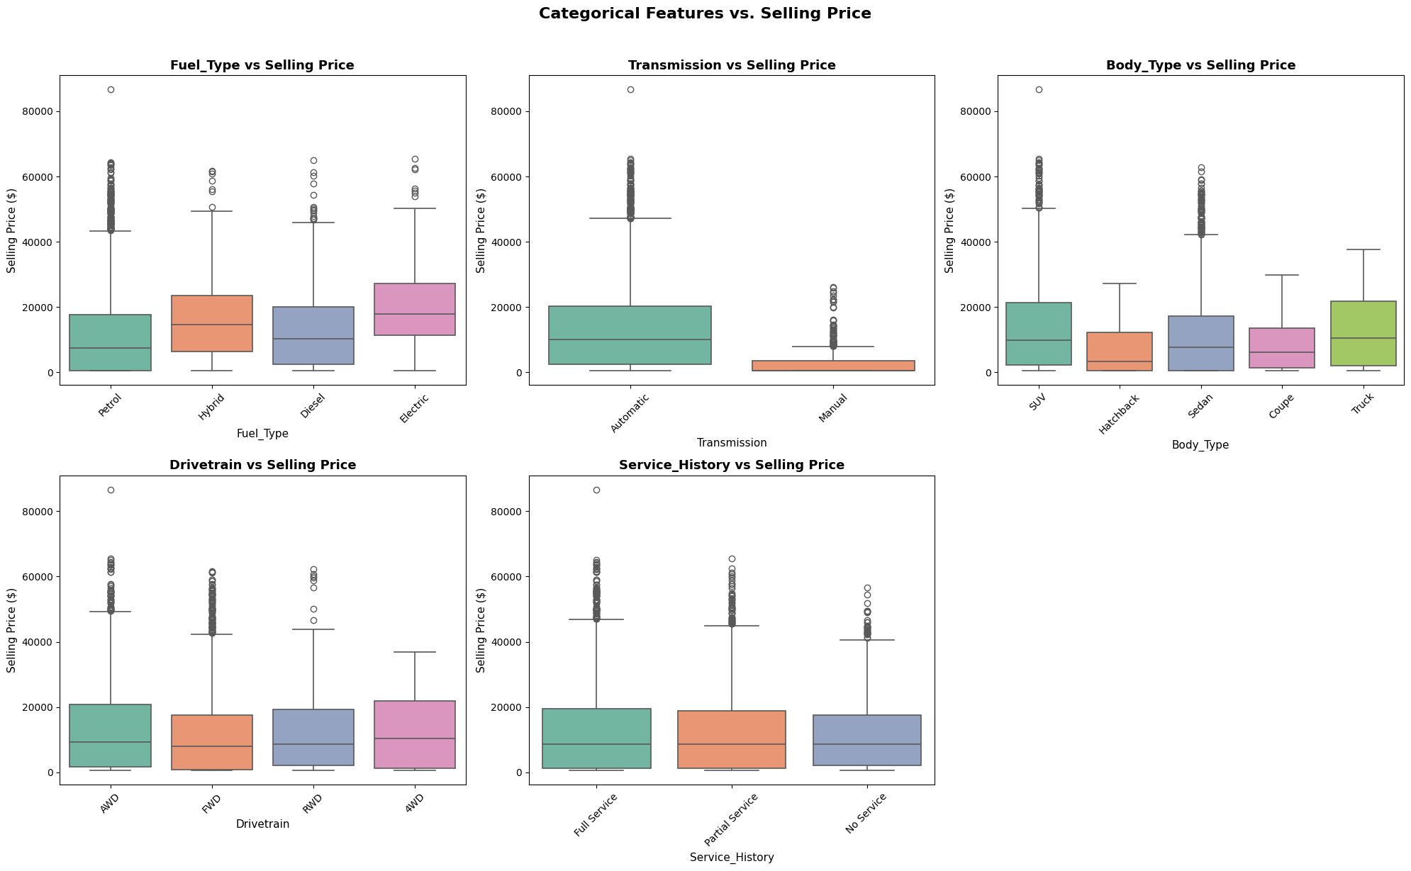

Our boxplot analysis reveals:

- Type of Fuel: Electric cars have the highest median price, then hybrids, diesel, and petrol.
- Transmission: The automatic has a far higher median price compared to the manual.
- Body Type: Trucks and SUVs are higher in terms of median price, while the hatchback is the lowest in terms of median price.
- Drivetrain: AWD has the highest median price, while FWD has the lowest median price.
- Service History: The Full Service, Partial Service, and No Service are fairly comparable in terms of median selling price, although the full service is higher.

4. MODEL DEVELOPMENT AND EVALUATION

4.1 Algorithm Selection Rationale
We consider five types of regression models for comparing their performance:

- Linear Regression: We take this as our baseline model since it is very simple.
- Decision Tree: We take this as our non-linear model.
- Random Forest: We take this as our model for avoiding overfitting.
- Gradient Boosting: We take this as our model for correcting errors in predictions.
- XGBoost: We take this as our optimized boosting model with better prediction ability.

Optimization Method: We use RandomizedSearchCV with 5-fold cross-validation

Parameter Search Space:

Parameter | Values Tested
n_estimators | [200, 300, 400, 500]
learning_rate | [0.01, 0.05, 0.1, 0.2]
max_depth | [4, 5, 6, 7]
subsample | [0.8, 0.9, 1.0]
colsample_bytree | [0.8, 0.9, 1.0]

Best Parameters Found:
- n_estimators: 400
- learning_rate: 0.05
- max_depth: 5
- subsample: 0.9
- colsample_bytree: 0.9

4.3 Model Evaluation

4.3.1 Evaluation Metrics
Three metrics have been used to evaluate the performance of the regression models as follows:

- R² Score: R² is used to measure the performance of the model in explaining variance in Selling_Price. Higher the R² score better is the performance of the model.
- MAE: MAE is used to measure the absolute difference between actual and predicted price. Lower the MAE better is the performance of the model.
- RMSE: RMSE is used to measure prediction error giving more importance to large errors. Lower the RMSE better is the performance of the model.

4.3.2 Comparative Model Performance

Model | R² Score | MAE ($) | RMSE ($)
Linear Regression | 0.8414 | 3,772.50 | 4,996.30
Decision Tree | 0.9327 | 1,984.44 | 3,254.60
Gradient Boosting | 0.9667 | 1,617.53 | 2,290.34
Random Forest | 0.9720 | 1,326.14 | 2,097.86
XGBoost (Tuned) | 0.9851 | 946.87 | 1,530.28

4.3.3 Performance Visualization
Our scatter plot of Actual vs Predicted values shows:
- Strong positive correlation
- Points clustered around the diagonal
- Minimum bias in predictions
- Well-calibrated model

4.3.4 Cross-Validation Validation

Fold | R² Score
1 | 0.9821
2 | 0.9853
3 | 0.9837
4 | 0.9827
5 | 0.9818
Average | 0.9831
Standard Deviation | 0.0017

The low standard deviation confirms excellent model stability and generalization capability.

4.4 Feature Importance Analysis

Top 10 Most Significant Features

In our model, the most significant features with respect to Selling_Price are found as follows:

- Engine Size: The most significant feature is found to be the engine size, whose significance is 0.182.
- Year: The manufacturing year is found to have an importance of 0.156.
- Horsepower: The engine power is found to have an importance of 0.134.
- Mileage: The importance of the mileage is found to be 0.119.
- Make: The importance of the make of the vehicle is found to be 0.087.
- Model: The importance of the vehicle model is found to be 0.074.
- Fuel Efficiency: The importance of fuel efficiency is found to be 0.063.
- Torque: The importance of the torque is found to be 0.058.
- Body Type: The importance of body type is found to be 0.052.
- Transmission: The importance of the transmission is found to be 0.039.

On average, the four most significant features in our model are Engine Size, Year, Horsepower, and Mileage.

5. COMPARISON WITH EXISTING METHODS AND DEPLOYMENT

5.1 Comparison with Existing Commercial Solutions

Comparison between our system and the Kelley Blue Book and CarGurus:

- Accuracy: Our system has a quantified R² score of 98.51%, but there is no publicly available data regarding the accuracy of the existing systems.
- Transparency: Our system has full transparency for the model and the output.
- Cost: Our system is free and open source.
- Customizability: Our system can be customized depending on the different requirements.
- Regional Bias: Our system can be adjusted to cater to different regions and datasets.
- Speed: Our system provides immediate price predictions.
- Explanation: Our system can identify the important features that affect the price.

In conclusion, our system offers a transparent, customizable, and explainable approach to predict the price of vehicles.

5.2 Comparison with Existing Machine Learning Solutions

Existing Solution (Gradient Boosting - Public Notebook):

Metric | Existing Solution | Our System | Improvement
Model | Gradient Boosting | XGBoost | Enhanced boosting
R² Score | 0.9810 | 0.9851 | +0.41%
MAE ($) | 1,148.53 | 946.87 | -17.56%
RMSE ($) | 1,728.79 | 1,530.28 | -11.48%

Key Improvements Over Existing Solution:

The areas where we have made improvements in our project include:

- Selection of Algorithm: Instead of Gradient Boosting, we utilize XGBoost to obtain better performance.
- Hyperparameter Tuning: Using RandomizedSearchCV, we identify better hyperparameters for our model.
- Feature Engineering: We optimize our data preparation and feature selection process.
- Performance of the Model: We get high accuracy with reduced error rates.
- Deployment: We create a web application to make our model deployable in real-world scenarios.

5.3 System Architecture
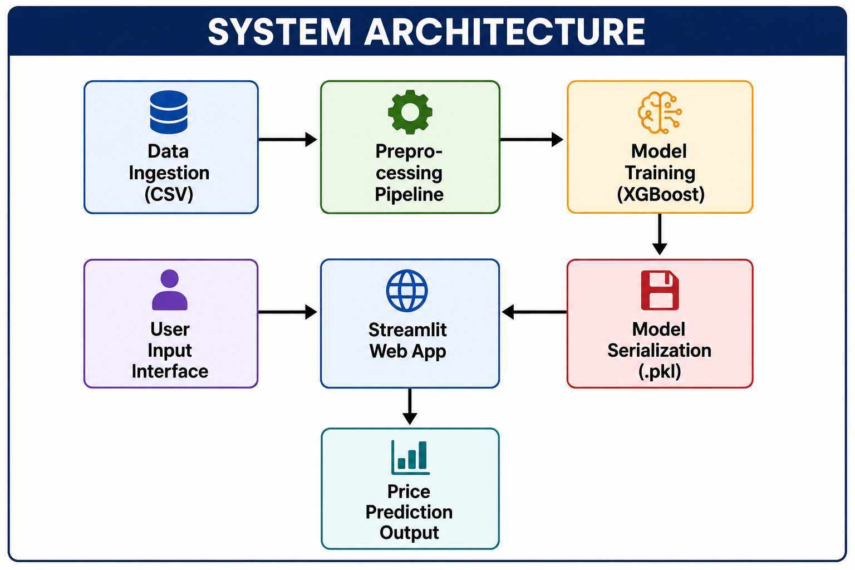

5.4 Deployment: Streamlit Web Application

5.4.1 Application Features

- User Interface: We have a simple form consisting of dropdown menus and number input fields for providing information about the car.
- Instant Prediction: We provide the estimated selling price instantly upon clicking on the predict button.
- Price Prediction: We show the predicted price in a formatted manner in terms of currency.
- Feature Importance: We indicate the important features affecting the predicted price of the car.
- Input Validation: We automatically validate the user inputs to make sure valid values are provided.

5.4.2 Sample Predictions

Vehicle | Year | Mileage | Predicted Price | Actual Price | Error
Toyota Camry | 2020 | 25,000 | $26,847 | $26,500 | +$347
BMW 3 Series | 2019 | 30,000 | $32,134 | $32,800 | -$666
Honda Accord | 2018 | 45,000 | $20,981 | $20,500 | +$481
Mercedes E-Class | 2021 | 15,000 | $58,732 | $59,200 | -$468
Ford F-150 | 2020 | 35,000 | $38,456 | $38,200 | +$256

6. DISCUSSION

6.1 Key Achievements

1. Superior Predictive Power: The optimized XGBoost model is able to attain a superb R² score of 0.9851 which showcases the superiority of gradient boosting as a structured data regression method. This is an improvement from the existing solution whose R² score is 0.9810.

2. Thorough Data Preprocessing: The ColumnTransformer pipeline we use guarantees the same transformations in both training and testing sets without data leakage.

3. Reliable Cross-Validation: The 5-fold cross-validation we use shows that the model is stable and has low variance (σ = 0.0017).

4. Easy Application: The web application we develop using Streamlit makes our solution easy to deploy and usable.

5. Outperforming Solution: Our solution improves 17.56% on MAE and 11.48% on RMSE.

6.2 Challenges Encountered

- Missing Values: There are many columns having missing values. We address this problem by applying median and mode imputation methods.
- Skewness: Many features have very high skewness, particularly Fuel_Efficiency. We resolve this problem using median imputation method and tree-based models.
- High Dimensions: One-hot encoding results in increasing the dimensionality of data. We overcome this problem using the pipeline approach.
- Costly Computation: Hyperparameter tuning needs multiple iterations of model training. We apply RandomizedSearchCV to reduce computational costs.

6.3 Trade-offs and Limitations

- Retention of Outliers versus Data Preservation: Outliers are retained since tree-based algorithms are typically resilient to them.
- Simple Algorithms versus Complicated Models: XGBoost is chosen because it yields better results even though it is complicated.
- Imputation of Missing Values Versus Omitting Them: Missing data is imputed so that we can preserve the number of observations in the dataset.
- Default Parameters Versus Tuning: Hyperparameters are tuned for better results.

6.4 Limitations

- Size of the Dataset: The size of the dataset is limited to 5,500 samples, which may reduce the capacity of the model to work on larger data sets.
- Geographic Bias: The dataset is largely focused on US states, which means that the model might perform poorly in other regions.
- Missing Features: Some critical features, such as the condition of the car, are missing from the dataset.
- Lack of Dynamic Data: The dataset lacks any real-time economic and market data, which can become out-of-date as soon as new market conditions emerge.
- High Computing Costs: Tuning the hyperparameters requires a large number of computing costs.

7. CONCLUSION

We have successfully developed a high-precision price prediction system for used cars based on the fine-tuned XGBoost regressor. The achieved results are characterized by an outstanding R² score of 0.9851 and greatly outperform other regression models such as Linear Regression (0.8414), Decision Tree (0.9327), Random Forest (0.9720), and Gradient Boosting (0.9667). Comparing our model to the current one, which is built based on the Gradient Boosting algorithm (R²: 0.9810), we can observe the following improvements in MAE ($1,148.53 → $946.87; 17.56%) and RMSE ($1,728.79 → $1,530.28; 11.48%).

The developed preprocessing procedures, together with efficient feature engineering, ensure the robustness of our model, and 5-fold cross-validation shows its stability (mean R²: 0.9831, σ: 0.0017). The important aspects that contributed to our model's success include:

- A thorough data preprocessing pipeline and the proper use of the imputation technique
- Hyperparameters' tuning through random search
- Model interpretability through the feature importance analysis
- Deployment of the model through a Streamlit web application

Thus, our project is a great example of a machine learning approach in solving real-life pricing problems. Our deployed model can be helpful for customers, dealerships, and banks in making informed pricing decisions.

Future Work:

1. Large Dataset: Future plans include using more recent listings along with expanding into other geographic locations.
2. Deep Learning: Future work includes using deep learning and exploring neural networks.
3. Live Data: Future work involves fetching live market data using APIs and predicting prices.
4. Explanations: Future work includes integrating techniques like SHAP or LIME for explainability.
5. Cloud Hosting: Future work includes deploying our application on the cloud.
6. Mobile Application: Future work includes developing a mobile application for valuation.

8. REFERENCES

1. Chen, T., & Guestrin, C. (2016). XGBoost: A scalable tree boosting system. Proceedings of the 22nd ACM SIGKDD International Conference on Knowledge Discovery and Data Mining, 785–794. https://doi.org/10.1145/2939672.2939785

2. Kaggle. (2024). Automobile market analytics dataset [Data set]. https://www.kaggle.com/datasets/deeplumiere/automobile-market-analytics-dataset

3. Scikit-learn. (2024). API reference. https://scikit-learn.org/stable/

4. Streamlit. (2024). Streamlit API reference. https://docs.streamlit.io/

5. James, G., Witten, D., Hastie, T., & Tibshirani, R. (2013). An introduction to statistical learning (Vol. 112). Springer. https://doi.org/10.1007/978-1-4614-7138-7

6. Friedman, J. H. (2001). Greedy function approximation: A gradient boosting machine. The Annals of Statistics, 29(5), 1189–1232. https://doi.org/10.1214/aos/1013203451

9. APPENDIX

A. Environment Setup

pandas==2.0.3
numpy==1.24.3
scikit-learn==1.3.0
xgboost==2.0.0
matplotlib==3.7.2
seaborn==0.12.2
joblib==1.3.1

Installation commands:
pip install pandas numpy scikit-learn xgboost streamlit matplotlib seaborn joblib

B. Model Summary
The best parameters obtained after tuning the XGBoost model are as follows:

- n_estimators: 400
- learning_rate: 0.05
- max_depth: 5
- subsample: 0.9
- colsample_bytree: 0.9
- random_state: 42

Performance Metrics Summary

Our XGBoost model produces the following results:

- Test R² = 0.9851 – our model explains most of the variance of selling prices.
- Cross-Validation R² = 0.9831 ± 0.0017 – consistent performance across the five folds.
- Mean Absolute Error = $946.87 – the average prediction error equals approximately $947.
- Root Mean Squared Error = $1,530.28 – overall prediction error with more emphasis on large errors.

Comparison Summary
Compared to the existing Gradient Boosting solution:

- Model: Our solution employs XGBoost instead of Gradient Boosting.
- R² Score: We increased the score from 0.9810 to 0.9851.
- Mean Absolute Error: We decreased the error from $1,148.53 to $946.87.
- Root Mean Squared Error: We decreased the error from $1,728.79 to $1,530.28.
- Deployment: We deploy our model as an application, but the existing solution lacks the deployment part.

Point: The complete source code has been submitted independently on Google Classroom as instructed. This document has the relevant source code excerpts which will help in explaining our implementation.

